Symmetric vs Asymmetric Encryption
Tasks
1.
Write a short note explaining the difference between symmetric and asymmetric encryption, and give one real-world example of where each might be used in a cloud app like WhatsApp or Paytm.
2.
Compare server-side encryption and client-side encryption by listing 3 pros and 3 cons for each method in the context of storing user photos on a cloud platform like Instagram.
3.
Set up an AWS S3 bucket (or use any cloud storage emulator like MinIO if you don't have an AWS account) and enable server-side encryption using AES-256 for all uploaded files. Upload a sample file and verify encryption is active.
4.
Simulate uploading a playlist cover image to your 'Spotify-style' S3 bucket with server-side encryption enabled, then use the AWS CLI or MinIO client to confirm the encryption status of the uploaded object.<br><br><em><strong>Hint:</strong> Use the 'aws s3api head-object' command or MinIO's object info command to check encryption metadata.</em>
5.
Use ChatGPT or Copilot to generate a code snippet in Python or Node.js that uploads a file to an S3 bucket with server-side encryption enabled. Test the code with your own file and explain how the encryption parameter works.

Answer : Task 1: Symmetric vs Asymmetric Encryption
Symmetric Encryption
- Uses one secret key to encrypt and decrypt data.
- It is fast and suitable for encrypting large amounts of data.

Example (Paytm):
When Paytm stores transaction logs or user files in cloud storage, it may use AES-256 symmetric encryption to protect the stored data.

Asymmetric Encryption
- Uses two keys:
  - Public Key (encrypts)
  - Private Key (decrypts)
- It is slower but more secure for sharing keys.

Example (WhatsApp):
WhatsApp uses asymmetric encryption during the key exchange process so users can communicate securely using end-to-end encryption.

Difference Table
Symmetric Encryption | Asymmetric Encryption
One key | Two keys
Faster | Slower
Used for encrypting data | Used for secure key exchange and digital signatures
Example: AES-256 | Example: RSA, ECC

Task 2: Server-side vs Client-side Encryption
Imagine Instagram storing user photos.
Server-Side Encryption (SSE)
The cloud server encrypts the photo after it is uploaded.
Pros
- Easy to use.
- No need to manage encryption in the app.
- Cloud provider handles encryption automatically.

Cons
- Cloud provider can access encryption keys.
- Less control over key management.
- Requires trusting the cloud provider.

Client-Side Encryption (CSE)
The photo is encrypted before uploading.
Pros
- Maximum privacy.
- Cloud provider cannot read the data.
- User controls encryption keys.
Cons
- More complex to implement.
- Losing the key means losing the data.
- More processing on the user's device.

Task 3: Create an AWS S3 Bucket with AES-256 Encryption

Step 1: Login
Sign in to the AWS Management Console.
Open S3.

Step 2: Create Bucket
Click
Create Bucket
Example:
spotify-style-storage
Choose your AWS Region.
Leave other settings as default.
Click
Create Bucket

Step 3: Enable Default Encryption
Open your bucket.
Go to
Properties
Scroll to
Default Encryption
Click
Edit
Select
Server-side encryption with Amazon S3 managed keys (SSE-S3)
Encryption Algorithm:
AES-256
Save changes.
Now every uploaded file will automatically be encrypted.

Step 4: Upload Sample File
Upload any file.
Example
sample.jpg
or
song.txt
After upload completes, encryption is already active.

Step 5: Verify Encryption
Open the uploaded object.
Look for
Server-side encryption
It should display
AES-256

Task 4: Simulate Uploading Playlist Cover Image
Suppose your bucket name is
spotify-style-storage
Image:
cover.jpg
Upload it.

Verify Using AWS CLI
Run:
aws s3api head-object \
--bucket spotify-style-storage \
--key cover.jpg
Look for this output:
{
"ServerSideEncryption": "AES256"
}
That confirms encryption is enabled.

If Using MinIO
Upload:
mc cp cover.jpg local/spotify-style-storage
Check object info:
mc stat local/spotify-style-storage/cover.jpg
Look for encryption information in the metadata.

Task 5: Python Code to Upload with Server-Side Encryption
Install boto3:
pip install boto3
Python code:
import boto3

# Create S3 client
s3 = boto3.client('s3')

# Upload file with server-side encryption
s3.upload_file(
'cover.jpg',
'spotify-style-storage',
'cover.jpg',
ExtraArgs={
'ServerSideEncryption': 'AES256'
}
)

print("Upload successful with AES-256 encryption.")

Test the Code
- Save as
upload.py
- Place
cover.jpg
in the same folder.
- Configure AWS CLI credentials:
aws configure
- Run:
python upload.py

Verify Again

aws s3api head-object \
--bucket spotify-style-storage \
--key cover.jpg
Expected output:
{
"ServerSideEncryption": "AES256"
}

How the Encryption Parameter Works
In the Python code:
ExtraArgs={
'ServerSideEncryption': 'AES256'
}
- ExtraArgs sends additional options with the upload request.
- ServerSideEncryption='AES256' tells Amazon S3 to encrypt the file using AES-256 after it is uploaded.
- S3 automatically encrypts the object before storing it and decrypts it transparently when an authorized user downloads it.
- This protects data at rest without requiring you to manage encryption yourself.

Expected Screenshots for Your Assignment
If your instructor asks for proof, capture screenshots of:
- S3 bucket creation.
- Default encryption showing AES-256.
- Uploaded file (cover.jpg or sample.jpg).
- AWS CLI output showing "ServerSideEncryption": "AES256".
- Python code execution showing a successful upload.

1. Symmetric vs Asymmetric Encryption
Diagram
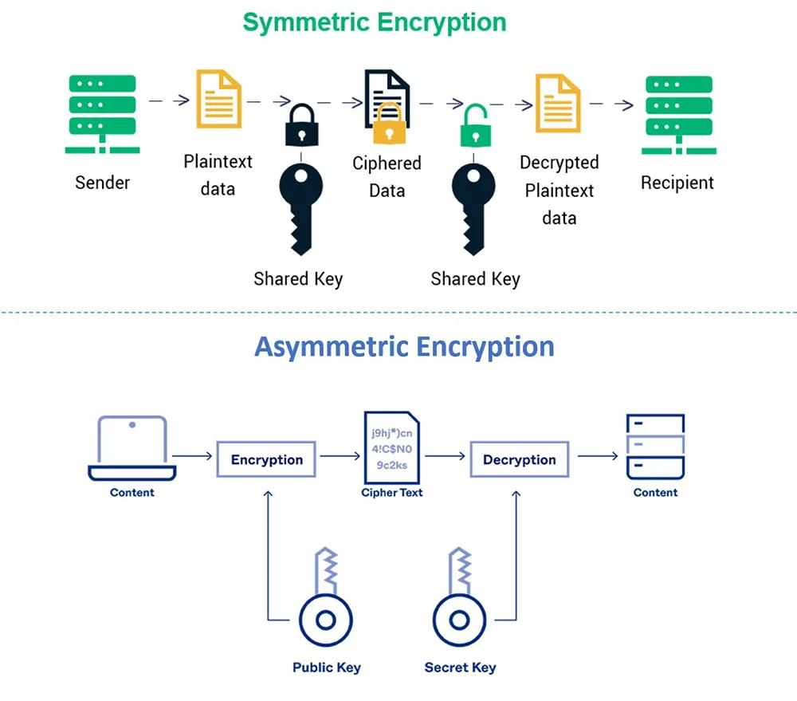
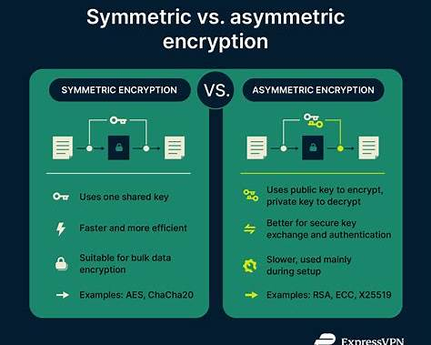

Example 1: Symmetric Encryption (AES-256)
Imagine Instagram stores your uploaded photo.
User
│
▼
Photo
│
Encrypt using Secret Key (AES-256)
│
Encrypted Photo
│
Stored in AWS S3
- One secret key encrypts and decrypts the photo.
- Very fast.
- Used for cloud storage encryption.
Real-world example:
- Instagram encrypting stored photos.
- Paytm encrypting transaction records.

Example 2: Asymmetric Encryption (RSA)
Imagine sending a WhatsApp message.
Alice
│
Uses Bob's Public Key
│
Encrypted Message
│
Internet
│
Bob uses Private Key
│
Original Message
- Uses two keys.
- Public key encrypts.
- Private key decrypts.
- Mainly used for secure key exchange and authentication.
Real-world example:
- WhatsApp exchanging encryption keys.
- HTTPS websites when you log in.

2. Server-Side Encryption (SSE)

Example
Your Computer
│
Upload Photo
│
▼
Amazon S3
│
Automatically Encrypts (AES-256)
│
Encrypted Storage
Here:
- You upload holiday.jpg.
- Amazon S3 encrypts it automatically before saving.
- When you download it later, S3 decrypts it automatically for authorized users.

3. Client-Side Encryption (CSE)

Example
Your Computer
│
Encrypt Photo
│
Encrypted Photo
│
Upload
│
Cloud Storage
Here:
- Your app encrypts the photo before uploading.
- The cloud provider only stores encrypted data.
- Only someone with your encryption key can read it.

4. AWS S3 AES-256 Encryption
Example Screenshot
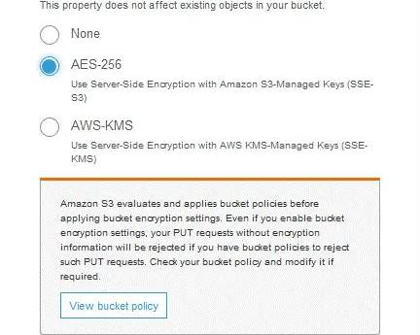
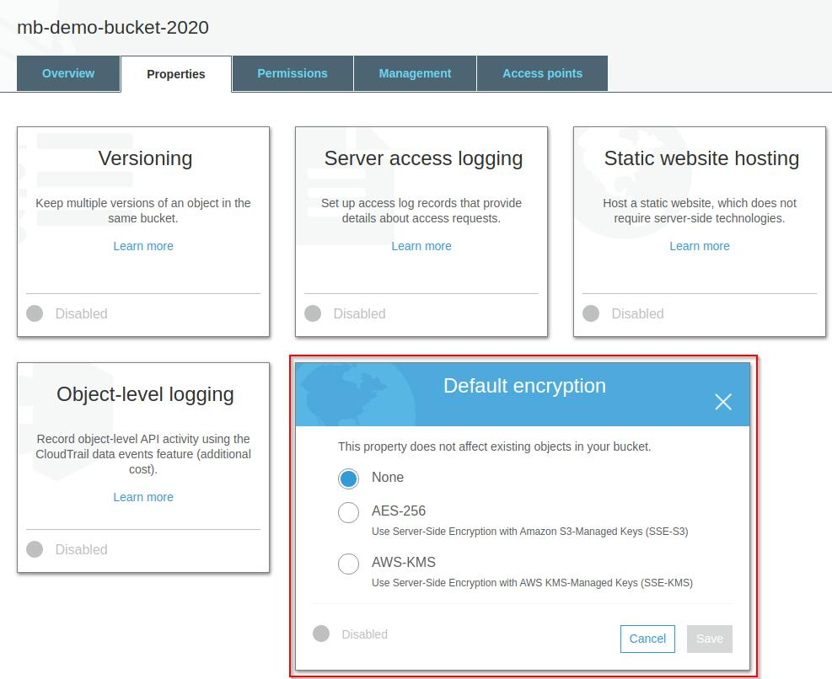
When enabling default encryption, select:
- AES-256
- Server-Side Encryption with Amazon S3 Managed Keys (SSE-S3)
Every new uploaded file will then be encrypted automatically.

5. Upload Example
Suppose your bucket is:
spotify-style-storage
Upload:
cover.jpg
AWS stores it like this:
cover.jpg
│
Upload
│
Amazon S3
│
AES-256 Encryption
│
Encrypted Object

6. Verify Encryption Using AWS CLI
Run:
aws s3api head-object \
--bucket spotify-style-storage \
--key cover.jpg
Example output:
{
"AcceptRanges": "bytes",
"LastModified": "2026-08-05T18:00:00Z",
"ContentLength": 145632,
"ETag": "\"abcd1234\"",
"ContentType": "image/jpeg",
"ServerSideEncryption": "AES256"
}
The line:
ServerSideEncryption": "AES256"
confirms that your file is encrypted.

7. Python Upload Example
import boto3

s3 = boto3.client("s3")

s3.upload_file(
"cover.jpg",
"spotify-style-storage",
"cover.jpg",
ExtraArgs={
"ServerSideEncryption": "AES256"
}
)

print("Upload completed successfully!")

How it works
ExtraArgs={
"ServerSideEncryption":"AES256"
}
This parameter tells Amazon S3:
"Encrypt this file using AES-256 server-side encryption before storing it."
You don't need to encrypt the file yourself—Amazon S3 handles encryption and decryption automatically for authorized users.

Simple Real-Life Analogy
Encryption Type | Real-Life Example
Symmetric | One house key is used to lock and unlock the same door.
Asymmetric | A mailbox: anyone can drop a letter in (public key), but only the owner can open it with a private key.
Server-Side Encryption | You give your luggage to the airport, and they lock it in a secure storage room.
Client-Side Encryption | You lock your suitcase yourself before giving it to the airline.

